TutorTube: Ideal Gas Laws (Gay-Lussac and Charles) Fall 2020
Introduction
Hello and welcome to TutorTube, where The Learning Center’s Lead Tutors help you understand challenging course concepts with easy to understand videos. My name is Ethan, Lead Tutor for chemistry and biology. In today’s video, we will explore Ideal Gas Laws. Let’s get started!
Objectives
First, we’ll look conceptually at the Ideal Gas Law that can be used to derive the four individual gas laws. Then, we’ll learn two of the four individual laws and some of their application.
Ideal Gas Law
The equation of the Ideal Gas Law is as such.
$$PV=nRT$$
This equation can tell us how gasses will behave as the conditions they are in change from one situation to another. Or, we can predict one variable of a gaseous mixture if we know all the others. The inputs are P for pressure, V for volume, n for number of moles, R for the gas constant, and T for temperature. We can use various units for pressure and volume; however, when we use this equation we need to be in Kelvin for temperature because pressure and volume depend on kinetic energy of particles, and Kelvin has 0 degrees as absolute 0. This means that there is no kinetic energy (or heat) at 0°K. Additionally, we usually want to use moles because the gas constant has units of moles most of the time.
Here is a dimensional analysis of the Ideal Gas Law. The unit for pressure is force per unit area. For volume, we have any measurement of length cubed, n is number of moles, the gas constant (R) has units of joules per mol· kelvin, and temperature has units of Kelvin.

$$PV=nRT$$

$$\frac{F}{A}·l^{3}=mol·\left(\frac{J}{mol·K}\right)·K$$

We can substitute in newton per meter squared for pressure, meter cubed for volume, and newton meter for joules. When we simplify this, we see that on the left-hand side meters squared cancels with meters cubed to leave just meters. On the right-hand side, moles cancel and Kelvin cancels. Then we are left with newton meter is equal to a newton meter, which is true. Of course, we can simplify to 1=1, but that isn’t really necessary. Here, the goal was just to check that all the units check out and we really do have a statement of equality.

$$(\frac{N}{m^{2}})·m^{3}=mol·\left(\frac{N·m}{mol·K}\right)·K$$

$$N·m=N·m$$

$$1=1$$

Now that we know the units, we can look at how each variable changes in relation to one another. First thing is that R will not vary; it’s a constant. So, we really only have four variables. Now, where these other variables are located can tell us how they are related to one another. Variables on opposite sides of the equation are directly proportional. This means that if you increase one while holding two others constant, the fourth variable will also increase. For example, take P in relation to n or T. If we keep v and n constant but increase P, then T has to increase to account for the increase in P. Also, if we keep V and T constant but increase P, then we know we have to increase n to account for the increase in P.
Conversely, variables on the same side of the equation are inversely proportional. Let’s use P and V. If we keep everything on the right-hand side constant but increase V, then P will have to decrease to account for the increase in V. So, the takeaway here is that we can increase volume to decrease pressure, or increase temperature to increase pressure, or increase number of moles to increase pressure, and so on.
Let’s go through a quick example using this equation. We’re given some volume of 10.0g of neon at 300mmHg and 40°C. What must be the volume? First, let’s write down what we’re given. We were given a mass of 10.0g, a pressure of 300mmHg, a temperature of 40°C, and we are trying to find volume. Always take a moment to write out what you’re given and what you’re looking for. Now, we need to get everything in the correct units. Instead of grams, we need number of moles. We can get moles from grams by dividing the number of grams by the molar mass of the Neon. This gives us 0.495 moles of Neon gas.
Next, we need our units of pressure in atm instead of mmHg if we want to use the gas constant value of 0.082. For every 1atm, there is 760mmHg. So, 300mmHg divided by 760 gives us 0.39atm. We also need to convert Celsius to Kelvin. Here, we know that to go from Celsius to Kelvin we can just add 273. Next, let’s rearrange our equation for volume and plug in our values. Here, I’m using the gas constant value of 0.082 because it has units of liters· atm per mole· Kelvin, and all those units match our units for our other variables. For our final answer, we end up getting a value of 32, and our units are in liters.

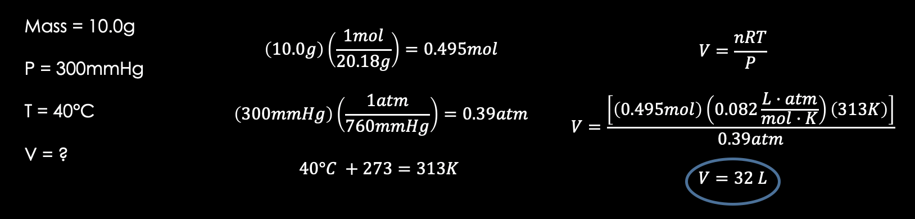
Figure 1: Solving first example question using the Ideal Gas Law formula PV = nRT.

So, we’ve seen that we can predict the value of one variable given the values of the others for one given situation, but what if we want to predict how things will change from one situation to another? We can simply rearrange our equation and label it to indicate two different situations. If we divide both sides of our equation by nT, we get PV/nT = R. Now we can set PV/nT equal to itself and specify situation one and situation two. From here, we can actually derive all the four individual laws that we will see here in a minute.
$$\frac{P_{1}V_{1}}{n_{1}T_{1}}=R \frac{P_{2}V_{2}}{n_{2}T_{2}}=R$$

$$\frac{P_{1}V_{1}}{n_{1}T_{1}}=\frac{P_{2}V_{2}}{n_{2}T_{2}}$$

Individual Gas Laws: Gay-Lussac
This is the first of the individual gas laws. The Gay-Lussac laws states that pressure is directly proportional to temperature when volume and number of moles are kept constant. In other words, if you have a fixed-volume container with a constant amount of gas, if you increase the temperature of that container, the pressure will increase. This is because higher temperature is the same as higher average kinetic energy. With more kinetic energy, gas particles are travelling faster and colliding into one another and the walls more forcefully. This means there is a higher pressure.
Like stated previously, the Gay-Lussac law says that by increasing temperature, we increase pressure if volume and number of moles are kept constant. So, the equation for this is P1/T1 = P2/T2. We can derive this from our Ideal Gas Law P1V1/n1T1 = P2V2/n2T2. If we cancel out v and n since those are constant, we get our equation P1/T1 = P2/T2.

$$\frac{P_{1}}{T_{1}}=\frac{P_{2}}{T_{2}}$$

Let’s solve a problem with this law. We have Helium gas that occupies a 20°C box with a pressure of 3atm. The box increases to 35°C. What is the new pressure? Well, we’re given an initial condition, a change, and we’re asked to find a final condition. Our initial temperature (T1) equals 20°C. Our initial pressure (P1) equals 3atm. And, our final temperature (T2) is 35°C. Let’s convert our temperatures to Kelvin first. Then, since we only have temperature and pressure here, that should signal to us that we need the Gay-Lussac law because it involves just temperature and pressure. Next, we can write out our equation, rearrange it for the final pressure (P2), and plug in the numbers. So, here we get 3.1atm. Let’s just do a quick reality check on our answer. We know that we increased the temperature so we should expect a proportional increase in pressure. And, that’s what we see. We went from 3atm to 3.1atm, so our answer is reasonable.
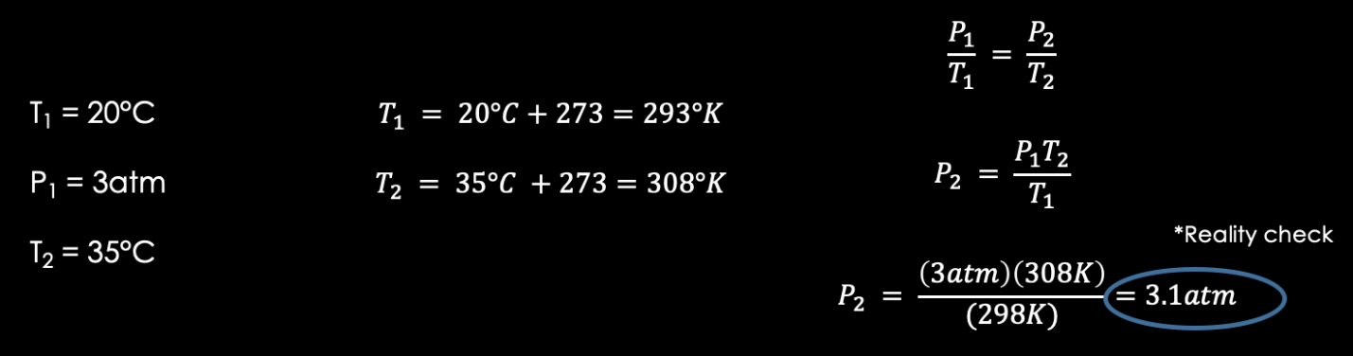
Figure 2: Solving example question for Gay-Lussac's law P1/T1 = P2/T2.

Individual Gas Laws: Charles
The next gas law is Charles Law. This one states that temperature is directly proportional to volume when pressure and number of moles are kept constant. So, if you have an adjustable volume full of gas and you heat it up, to maintain constant pressure and amount of gas, the volume must increase.
Here is the equation for Charles Law. It is V1/T1 = V2/T2. Again, we can derive it by just using the Ideal Gas Law Equation by eliminating P and n since those are kept constant.

$$\frac{V_{1}}{T_{1}}=\frac{V_{2}}{T_{2}}$$

Here’s an example problem using Charles Law. We’re given a sample of carbon dioxide in a pump with a volume of 25.0mL at 37°C. When the amount of gas and pressure remain constant, find the new volume of the carbon dioxide in the pump if temperature is increase to 67°C. So, our V1 is 25.0mL, T1 is 37°C, n and P are constant, and V2 is what we’re looking for. Let’s convert our temperatures to Kelvin. Since we only have volume and temperature, we know it involves Charles Law. We can rearrange our equation for V2, plug in, and solve. Here, we get a new volume of 27mL. Again, we want to do a reality check. We increased the temperature, so the volume will have to increase. We went from 25.0mL to 27mL, so we’re good.

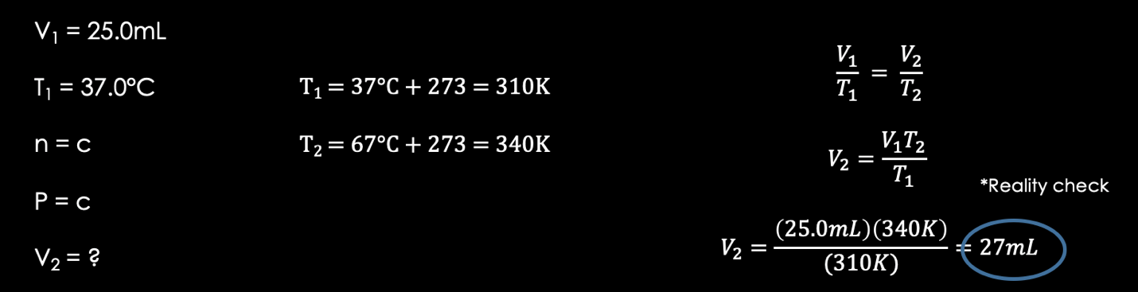
Figure 3: Solving example question using Charles Law V1/T1 = V2/T2.

Here are some good resources for all things related to Ideal Gas Law and the four individual gas laws. This link is provided in the description box below. It has various different units that you can use and values of R depending on what units you are given. Also, be sure to check the description for the second video in this series covering the Ideal Gas Law. In that second video, we will learn the last two individual gas laws as well as a more complicated example.

https://chem.libretexts.org/Bookshelves/Physical_and_Theoretical_Chemistry_Textbook_Maps/Supplemental_Modules_(Physical_and_Theoretical_Chemistry)/Physical_Properties_of_Matter/States_of_Matter/Properties_of_Gases/Gas_Laws/The_Ideal_Gas_Law

Outro
Thank you for watching TutorTube! I hope you enjoyed this video. Please subscribe to our channel for more exciting videos. Check out the links in the description below for more information about The Learning Center and follow us on social media. See you next time!

